**Machine Learning Case Study**

M. Ruthvik Reddy

CB.SC.P2AIE25013

**K-Nearest Neighbors**

K-Nearest Neighbors (KNN) is a non-parametric, supervised learning algorithm that predicts a label or value for a new point by looking at the labels/values of its k closest training examples and aggregating them (majority vote for classification, mean for regression)

**How it works:**

* Store the labeled training data; there is no explicit model fitted, which is why KNN is often called a lazy, instance-based learner.
* Define a distance metric (Euclidean Distance, Manhattan Distance, or Minkowski distance) and, for a query point, find its k nearest neighbors under that metric.
* For classification, assign the class by plurality/majority vote of those neighbors; for regression, predict the average of their target values.

**Case Study**

**Dataset and Processing:** In this case study for KNN Cancer Dataset was used. And it contains 32 different features, namely:

| ['id', 'diagnosis', 'radius_mean', 'texture_mean', 'perimeter_mean', 'area_mean', 'smoothness_mean', 'compactness_mean', 'concavity_mean', 'concave points_mean', 'symmetry_mean','fractal_dimension_mean', 'radius_se', 'texture_se', 'perimeter_se', 'area_se', 'smoothness_se', 'compactness_se', 'concavity_se', 'concave points_se', 'symmetry_se','fractal_dimension_se', 'radius_worst', 'texture_worst','perimeter_worst', 'area_worst', 'smoothness_worst', 'compactness_worst', 'concavity_worst', 'concave points_worst','symmetry_worst', 'fractal_dimension_worst', 'Unnamed: 32'] |
| --- |

* From these features 'diagnosis' is considered to be dependent feature, where it is to be found.
* And there are two features 'id' and 'Unnamed: 32' which are unnecessary, as these features do not provide any value to the predictions.
* After removing unnecessary features, below are the columns present:

| ['diagnosis', 'radius_mean', 'texture_mean', 'perimeter_mean', 'area_mean', 'smoothness_mean', 'compactness_mean', 'concavity_mean', 'concave points_mean', 'symmetry_mean','fractal_dimension_mean', 'radius_se', 'texture_se', 'perimeter_se', 'area_se', 'smoothness_se', 'compactness_se', 'concavity_se', 'concave points_se', 'symmetry_se','fractal_dimension_se', 'radius_worst', 'texture_worst','perimeter_worst', 'area_worst', 'smoothness_worst', 'compactness_worst', 'concavity_worst', 'concave points_worst','symmetry_worst', 'fractal_dimension_worst'] |
| --- |

* Now Considering y as 'diagnosis' and other features as X, then split them into X_train, X_val, y_train, y_val, in this 95% of data was considered for training and other 5% was considered for validation (or testing).

**KNN**

To find the best possible K value

| **error_rates = [] k_values = range(1, 21) # Test k from 1 to 20  for k in k_values:  knn = KNeighborsClassifier(n_neighbors=k, metric="euclidean")  knn.fit(X_train, y_train)  y_pred = knn.predict(X_val)  error_rates.append(1 - accuracy_score(y_val, y_pred))  min_error = min(error_rates) optimal_k = k_values[error_rates.index(min_error)] print(f"Optimal K: {optimal_k} with Minimum Error Rate: {min_error:.4f}")** |
| --- |

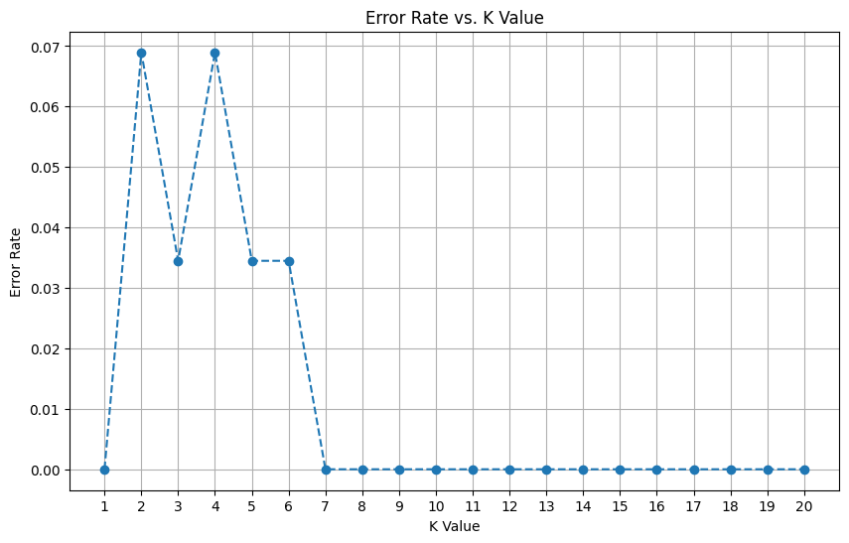

* And k=1 was giving minimum error rate, but k=7 is considered as it also has minimum error rate and to consider multiple neighbors.

For the case study, the data was tested with KNN with three different distance metrics: Euclidean Distance, Manhattan Distance, Cosine Distance. And here are the classification reports for these different distances:

| Classification Report (knn_euclidean):   precision recall f1-score support   0 1.00 1.00 1.00 6  1 1.00 1.00 1.00 23   accuracy 1.00 29  macro avg 1.00 1.00 1.00 29 weighted avg 1.00 1.00 1.00 29 |
| --- |

| Classification Report (knn_manhattan):   precision recall f1-score support   0 1.00 1.00 1.00 6  1 1.00 1.00 1.00 23   accuracy 1.00 29  macro avg 1.00 1.00 1.00 29 weighted avg 1.00 1.00 1.00 29 |
| --- |

| Classification Report (knn_cosine):   precision recall f1-score support   0 1.00 1.00 1.00 6  1 1.00 1.00 1.00 23   accuracy 1.00 29  macro avg 1.00 1.00 1.00 29 weighted avg 1.00 1.00 1.00 29 |
| --- |

**Conclusion:** So, for every distance metric used inferred the same outcome, and every KNN model predicted correct outcomes with 100% accuracy (based on the classification reports). And the best K value was found with iterating over with all possible K values, which provided the best K value with the least error rate.